|  |  |  |  |  |
| --- | --- | --- | --- | --- |
| **Test Case** | **Execution History** | | | |
| **Start Date** | **Start Time** | **End Time** | **Status** |
| **TC01-Verifying the functionality of SignIn** | **21/01/2019** | **17:27:23** | **17:27:23** | **Passed** |

|  |  |  |  |
| --- | --- | --- | --- |
| **Step Description** | **Expected Result** | **Actual Result** | **Status** |
| Step: Open the woolworths mobi one application | Application should open | Application opened as expected | **Passed** |

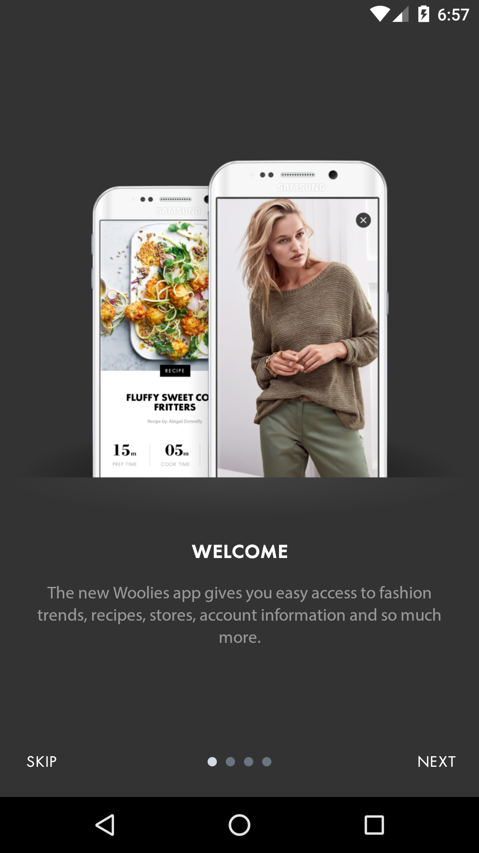

|  |  |  |  |
| --- | --- | --- | --- |
| **Step Description** | **Expected Result** | **Actual Result** | **Status** |
| Step: Click on skip to close the skip page | Skip page should be closed | Skip Page closed as expected | **Passed** |

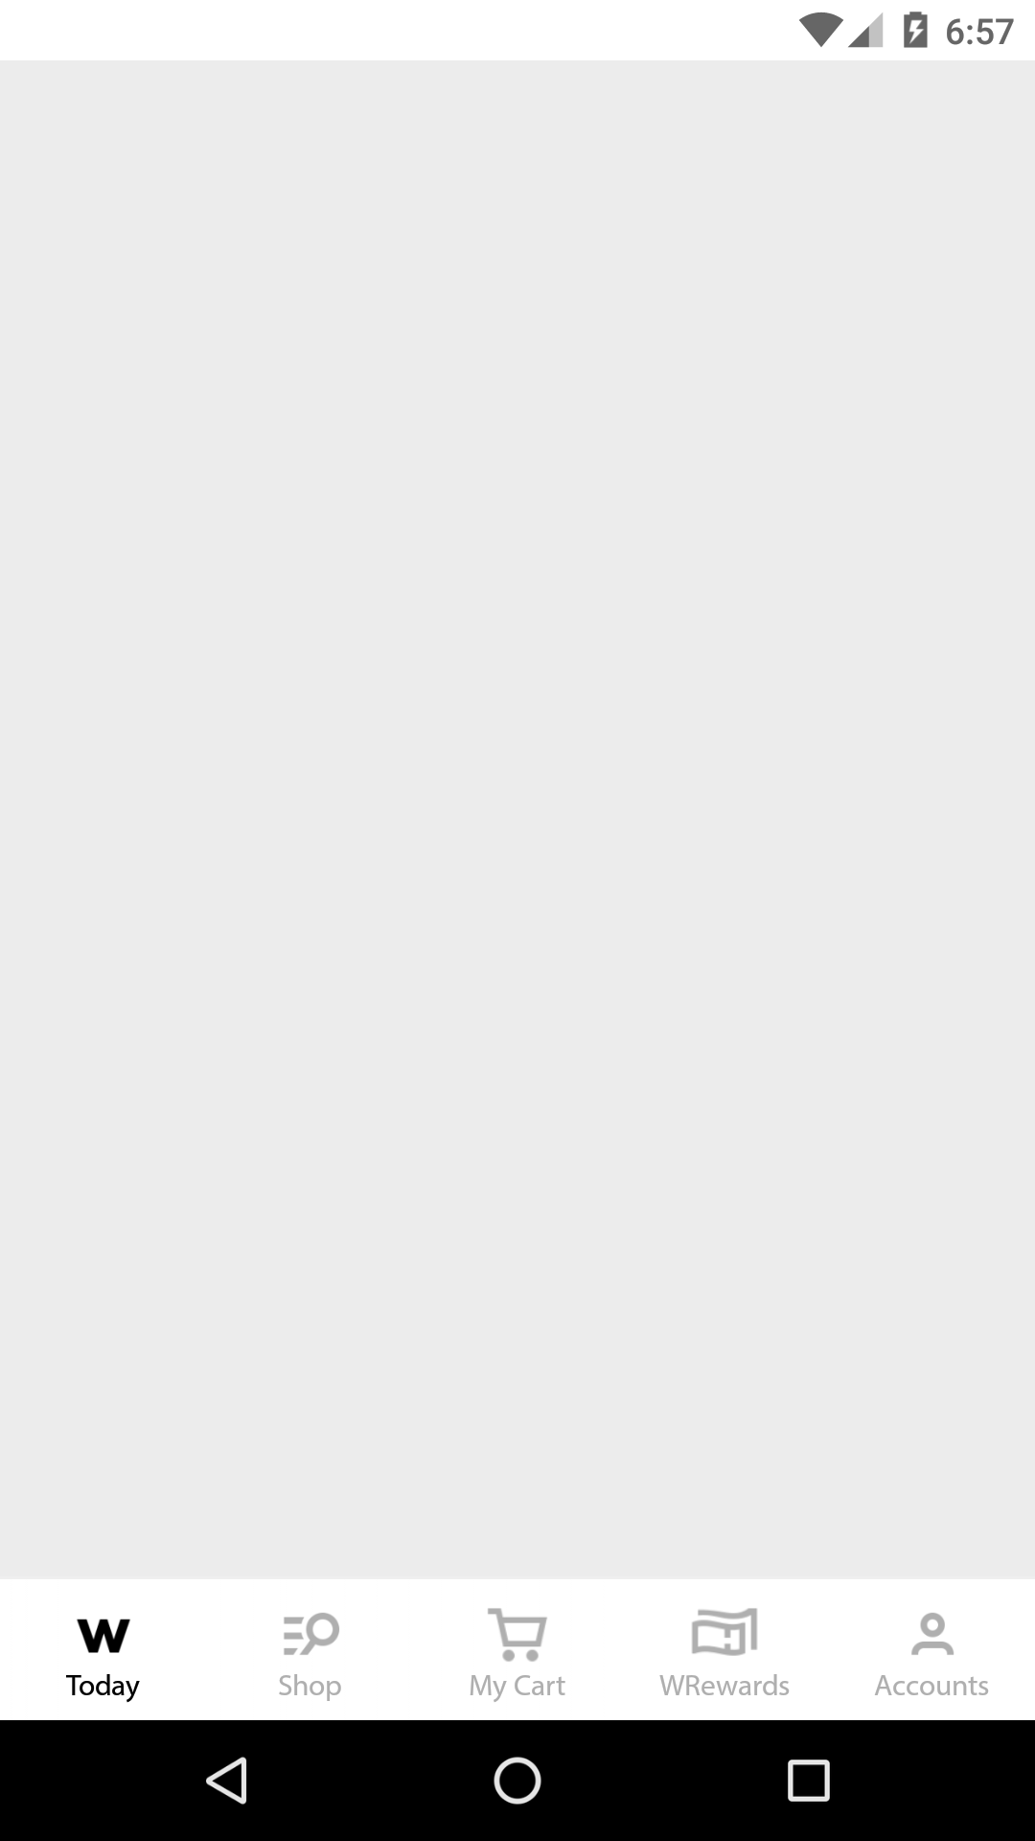

|  |  |  |  |
| --- | --- | --- | --- |
| **Step Description** | **Expected Result** | **Actual Result** | **Status** |
| Step: Click on Account | Account page should display | As Expected | **Passed** |

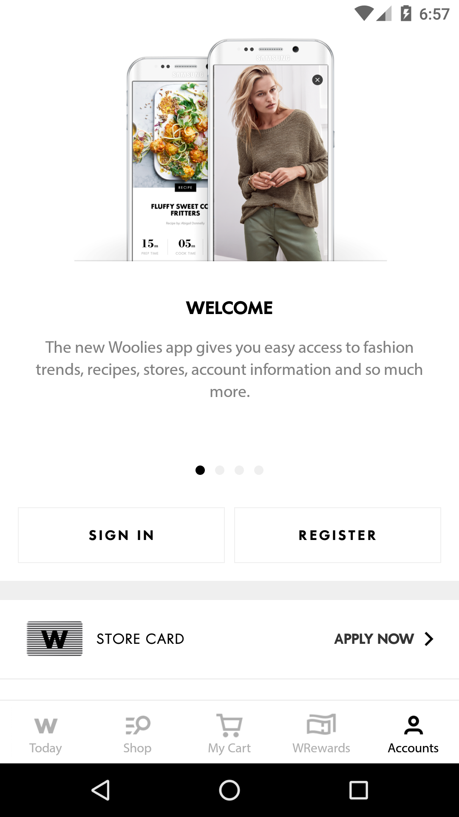

|  |  |  |  |
| --- | --- | --- | --- |
| **Step Description** | **Expected Result** | **Actual Result** | **Status** |
| Step:Click on SignIn | Sign In page should display | As Expected | **Passed** |

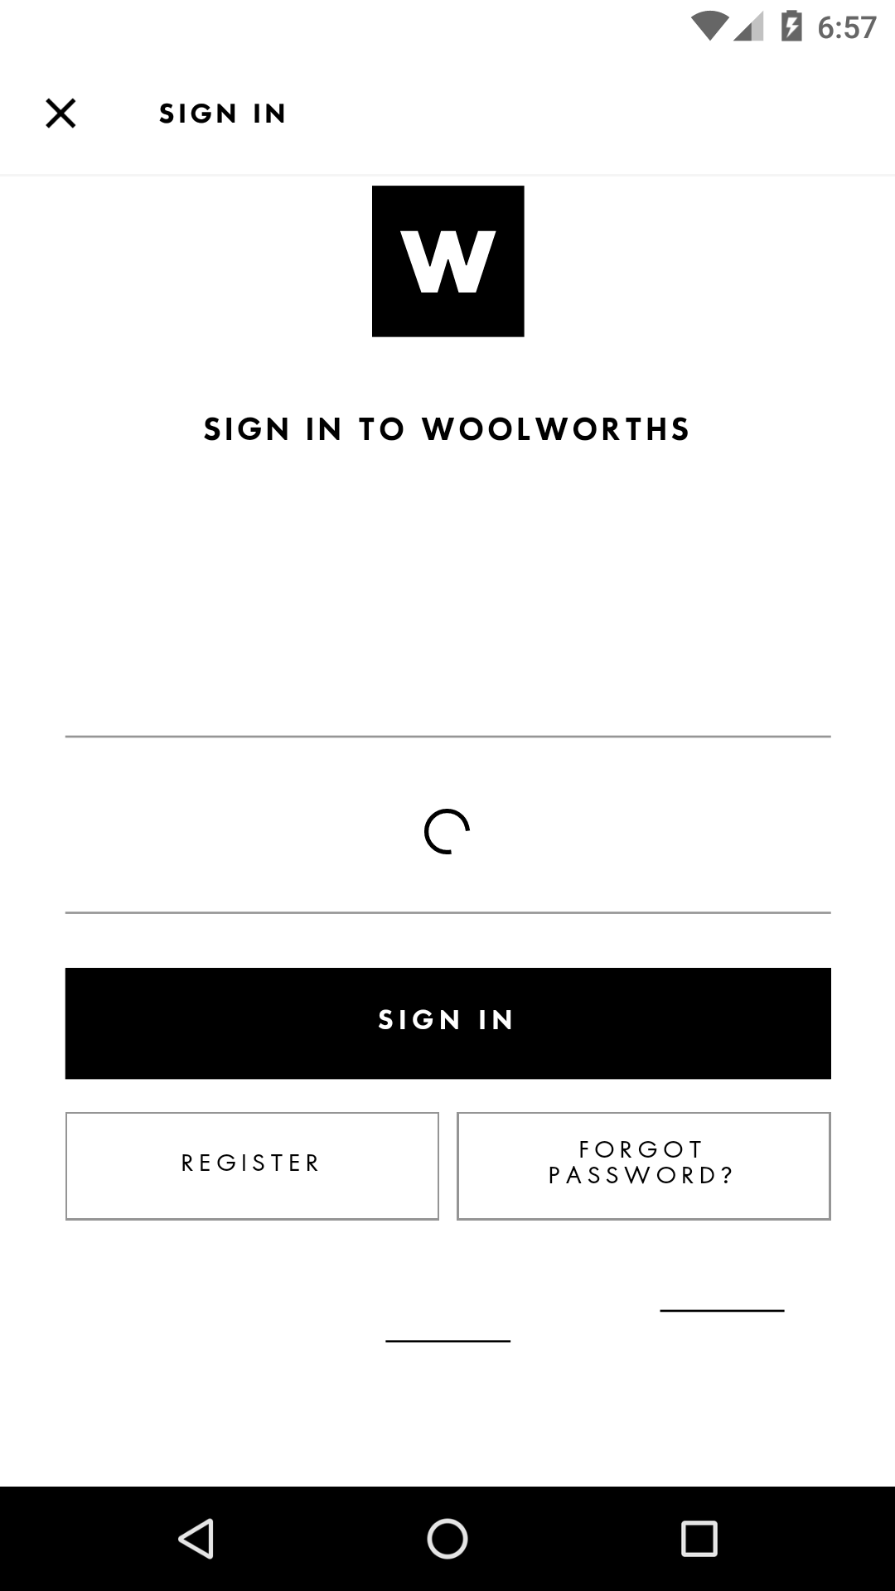

|  |  |  |  |
| --- | --- | --- | --- |
| **Step Description** | **Expected Result** | **Actual Result** | **Status** |
| Step: Enter the valid userName and valid password in the respective fields | Username and passowrd field should accept the values | As Expected | **Passed** |

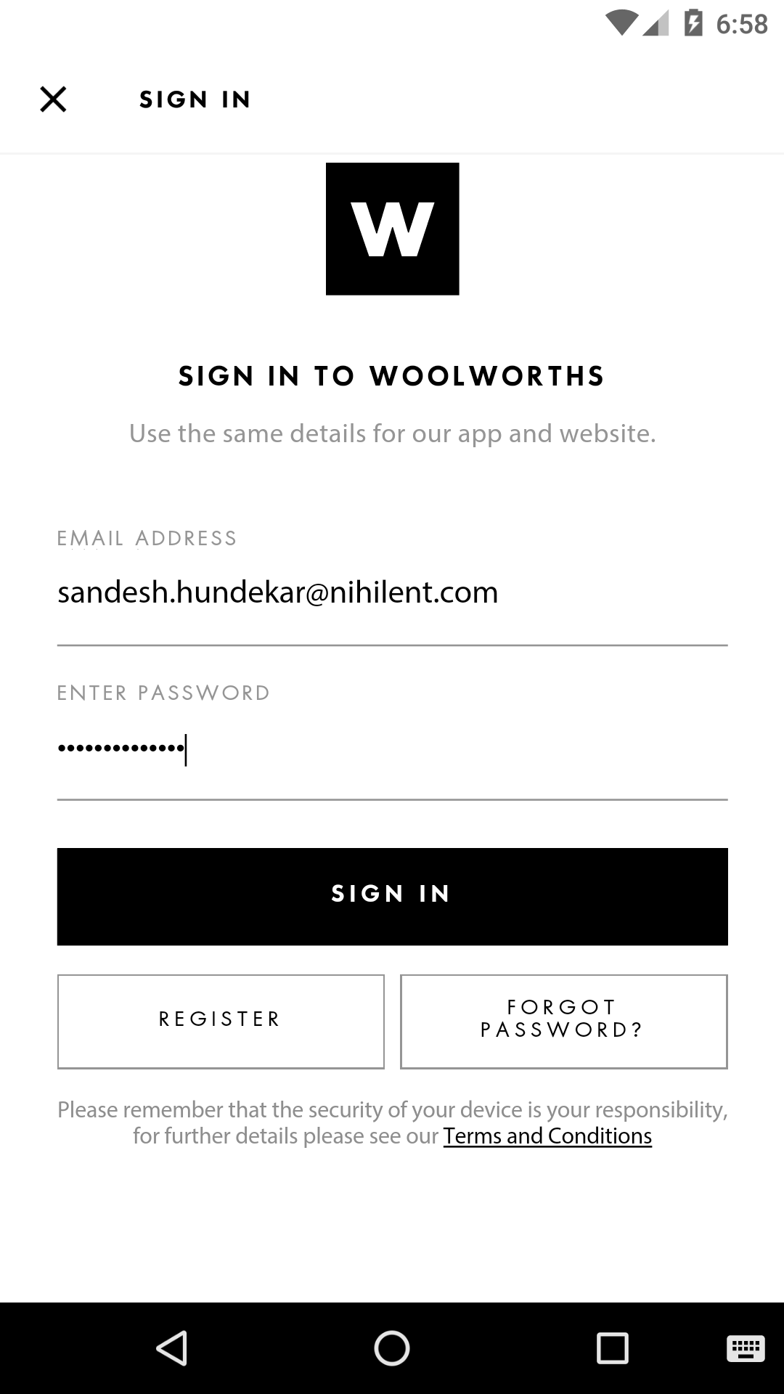

|  |  |  |  |
| --- | --- | --- | --- |
| **Step Description** | **Expected Result** | **Actual Result** | **Status** |
| Step: Click on Sign In button to login into account | User should be logged in successfully and user account home page should be display | As Expected | **Passed** |

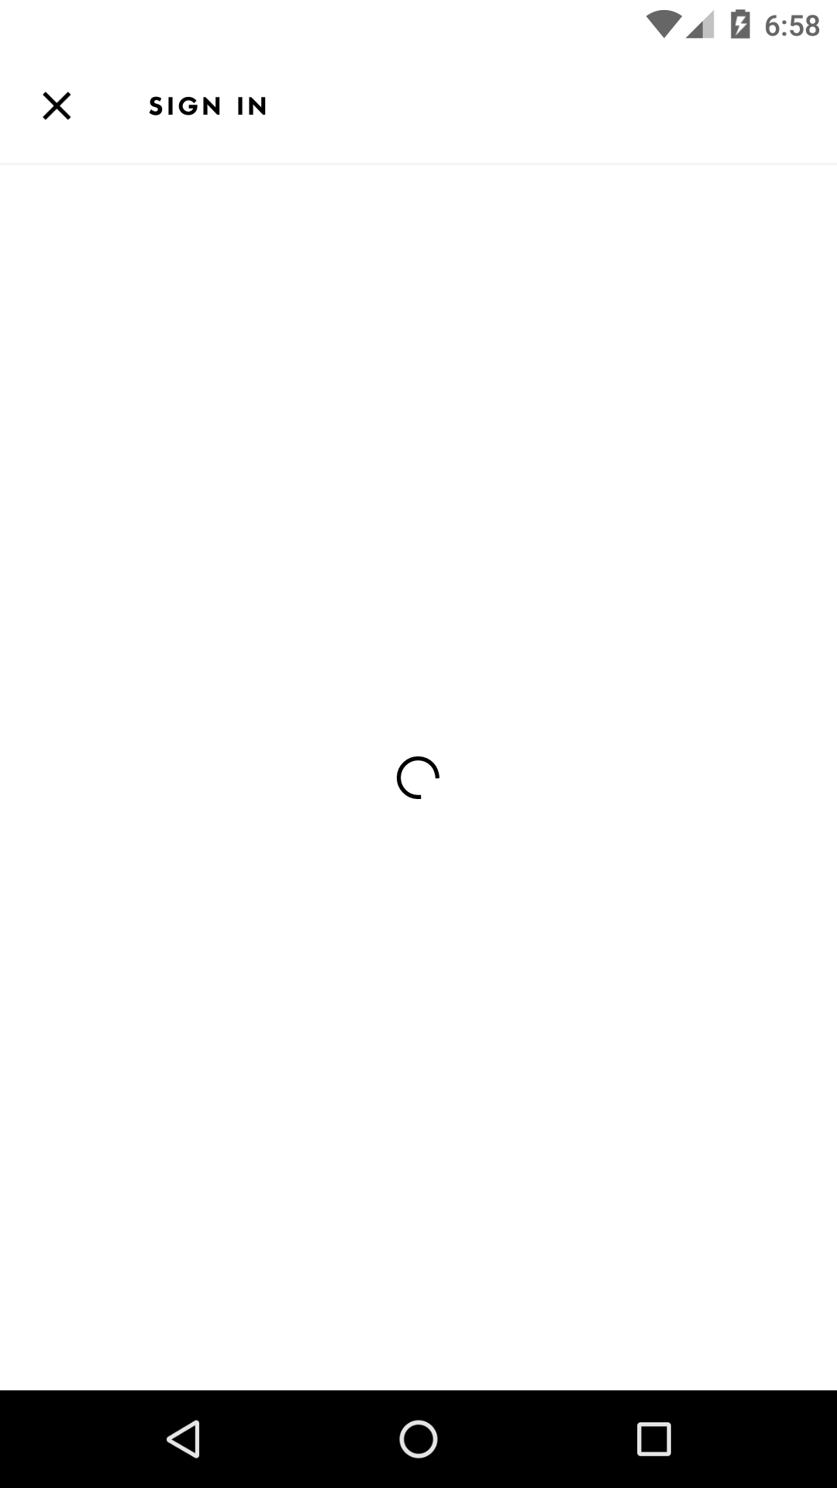

|  |  |  |  |
| --- | --- | --- | --- |
| **Step Description** | **Expected Result** | **Actual Result** | **Status** |
| Step:Click on Account | Account page should display | As Expected | **Passed** |

